Audit Based - Application



C-DAC’s Post Graduate Diploma in IT Infrastructure Systems and Security (PG-DITISS)
BATCH AUGUST 2025 - FEBRUARY 2026

GUIDANCE BY
DHEERAJ SADAWARTE

SUBMITTED BY
- BHAVANA MADARSE ( Reg.No-250850323006)
- KATRU TIRUMALA VENKAT ( Reg.No-250850323011)
- HIMANSHU BARFA ( Reg.No-250850323010)
- AMIT YADAV ( Reg.No-250850323003)

ABSTRACT

The Audit Based Application is a cybersecurity focused project designed to review the security configurations of network infrastructure devices against baseline hardening benchmarks. Network devices such as routers and switches play a critical role in organizational communication and security; however, improper or default configurations can introduce serious vulnerabilities. This project implements a standardized audit approach using CIS (Center for Internet Security) Benchmarks to assess the compliance of Cisco routers and switches.
The application analyzes device configurations, compares them against predefined CIS security controls,identifies misconfigurations, and generates compliance results along with security recommendations. The project aims to identify the compliance gaps against baseline hardening benchmark to improve security posture, reduce configuration errors, and provide a structured audit framework suitable for academic and real- world environments.

TABLE OF CONTENTS

CHAPTER NO | TITLE | PAGE NO
 | ABSTRACT | 2
1 | SOFTWARE REQUIREMENT SPECIFICATION | 4 - 5
2 | FEASIBILITY STUDY | 6
3 | SYSTEM ARCHITECTURE | 7
 | FLOW CHART OF THE PROJECT | 8
4 | METHODOLOGY | 9 - 10
5 | DATABASE DESIGN | 11 - 12
6 | EXECUTABLE CODES | 13
7 | RESULTS AND ANALYSIS | 14 - 15
8 | CONCLUSION | 16
 | SOURCE CODE & OUTPUT | 17 - 21
 | REFERENCES | 22

CHAPTER 1

Software Requirements Specification

  - Introduction:

The Audit Based Application is a Cybersecurity focused project designed to evaluate and verify the configurations of network devices with respect to baseline hardening standards. The application performs audits by comparing existing configurations against predefined security standards and best practices to identify vulnerabilities and compliance gaps.

Purpose:

The purpose of this project is to design and develop an application that automates the security audit process, reduces manual effort, and ensures consistent evaluation of systems against security benchmarks.

Problem Statement:
Frameworks such as CIS Benchmarks provide well-defined security guidelines, but manually reviewing device configurations against these standards is time-consuming, error-prone, and requires expert knowledge.
There is a need for an automated solution that can analyze network device configurations and verify compliance with CIS security benchmarks.
Commercial configuration assessment tools are available but often produce high false-positive rates..
Manual audit/review of network devices is time-consuming process.

Objectives:

To design and develop an application that reviews network device configurations.
To validate Cisco router and switch configurations against CIS Benchmark and standards.
To identify compliant and non-compliant configuration parameters.
To generate clear and structured compliance reports.
To assist network administrators and students in understanding security gaps in device configurations.
To reduce manual effort and human error in configuration auditing.

Scope:
The project uses CIS Benchmarks as the reference standard and is implemented using the Python programming language.

The Audit Based Application performs configuration-based security audits on network devices using predefined security checklists. The application focuses on identifying misconfigurations, assessing compliance, and generating audit results and recommendations.

Intended Users:

Cyber security Auditors
System and Network Administrators IT Security Teams
Academic Users and Students

System Requirements:

Hardware Requirements:

    - Standard PC or Laptop Software Requirements:
Python 3.x
Cisco Packet Tracer / GNS3
Text editor / IDE

Router:
A router is a networking device used to connect multiple networks.
It works at the Network Layer (Layer 3) of the OSI model.
Routers forward data packets based on IP addresses.
They help in selecting the best path for data transmission.
Routers provide security using ACLs, routing authentication, and secure management (SSH).
In this project, routers are audited to verify secure configuration and compliance using CIS benchmarks.

Switch:
A switch is a networking device used to connect devices within the same network.
It operates at the Data Link Layer (Layer 2) of the OSI model.
Switches forward data based on MAC addresses.
They support VLANs to segment networks and improve security.
Switches provide internal security using port security, STP, and access control features.
In this project, switches are audited to ensure secure internal network communication as per CIS benchmarks.

CHAPTER 2

FEASIBILITY STUDY

Technical Feasibility:
The Audit Based Application is technically feasible as it uses well-established and widely supported technologies. The project is implemented using Python, which provides strong support for automation, data parsing, and security analysis. CIS Benchmarks are clearly documented and can be easily mapped to audit checklists. The application does not require complex hardware and can be executed on standard computing systems. Hence, the technical implementation of the project is practical and achievable.

Operational Feasibility:
The system is operationally feasible because it is simple to use and requires minimal user training. Network administrators and security auditors can easily understand the audit process and interpret the results. The checklist-based approach simplifies security verification and reduces dependency on individual expertise. The application improves efficiency by standardizing audits and minimizing manual effort.

Economic Feasibility:
The project is economically feasible as it uses open-source tools and technologies. Python is free and does not require any licensing costs. No additional hardware or paid software is needed to implement the system. Therefore, the development, deployment, and maintenance costs are minimal, making the project cost-effective.

Schedule Feasibility:
The project is schedule feasible as it can be completed within the allotted academic time frame. The development tasks such as checklist preparation, audit logic implementation, database design, and report generation are manageable and well- defined. The project plan allows sufficient time for testing and documentation, ensuring timely completion.

Legal and Ethical Feasibility:

The project is legally and ethically feasible as it follows standard cybersecurity practices and does not involve unauthorized access to systems. The audit process is based on configuration analysis and uses publicly available security standards such as CIS Benchmarks. No sensitive or personal user data is collected or misused.

CHAPTER 3

System Architecture

The system architecture of the Audit Based Application defines the overall workflow used to perform security audits on network device configurations. The architecture is designed to process configuration files, evaluate security compliance, and generate audit reports in a structured manner.

User Uploads Configuration File:
The audit process begins when the user uploads a network device configuration file in text format. This configuration file serves as the input for the audit system. The system verifies the file format to ensure that it is valid and suitable for further processing.

Parsing Engine Processes Configuration:
Once the configuration file is uploaded, it is processed by the parsing engine. The parsing engine reads and normalizes the configuration data, extracts relevant parameters, and prepares the information in a structured format. This step ensures that the configuration is correctly interpreted before security evaluation.

Rule Engine Compares Against CIS Benchmark Rules:
The structured configuration data is then passed to the rule engine. The rule engine loads predefined CIS Benchmarks security rules and compares them against the actual device configuration. Each security control is evaluated and classified as PASS, FAIL, or MANUAL based on compliance with the security standards.

Compliance Report Generation:
After rule evaluation, the system generates a compliance report. The report summarizes audit results, compliance scores, risk levels, and security recommendations. Reports are generated in user-friendly formats such as CSV and HTML, providing clear insights into the security posture of the audited device

FLOW CHART OF THE PROJECT

The flowchart represents the complete workflow of the Audit Based Application, starting from configuration file upload to report generation.
It shows how device configurations are analyzed using CIS benchmarks to evaluate compliance and generate audit results.

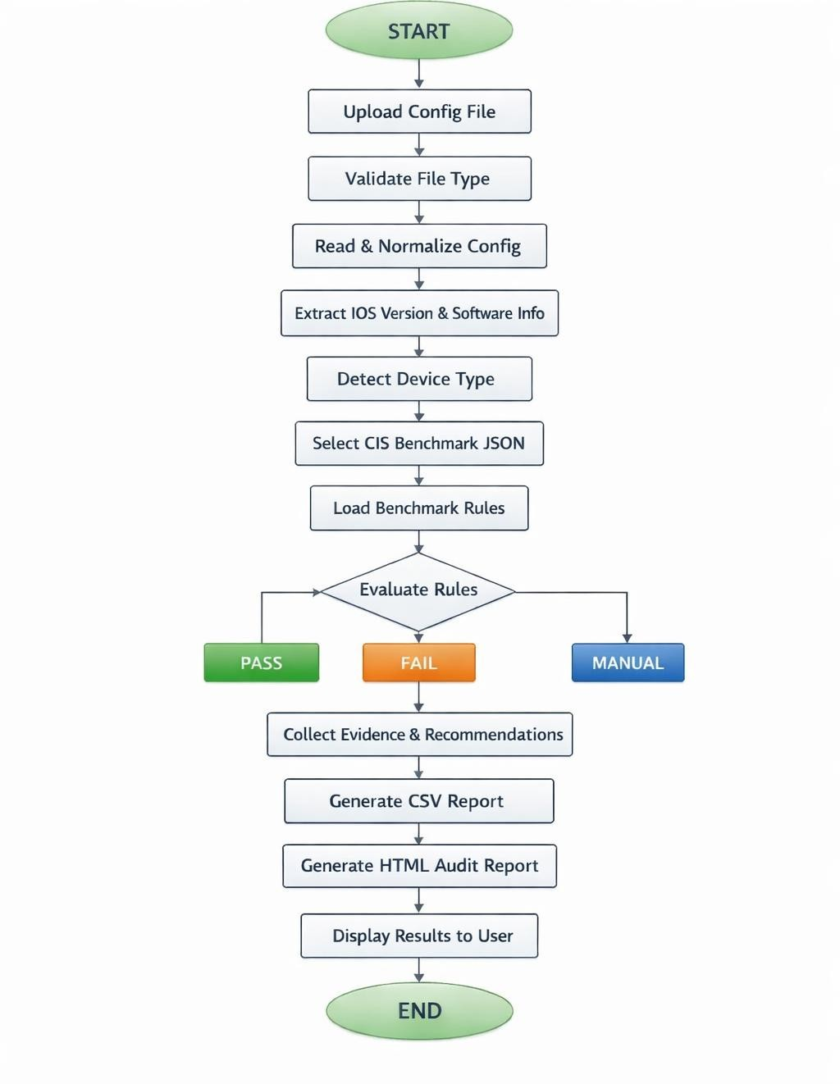
Fig.no 1

CHAPTER 4

METHODOLOGY

The methodology adopted for the Audit Based Application follows a structured and systematic approach to ensure accurate and reliable security auditing of network devices. The first step involves the collection of CIS Benchmarks and CIS (future enhancement) guidelines, which provide standardized and well-defined security configuration requirements for routers and switches. These guidelines serve as the reference framework for evaluating device security.

Based on the collected standards, relevant security rules are defined for auditing network device configurations. Each rule specifies the expected secure configuration, risk severity, and recommended remediation. These rules are structured in a machine- readable format to support automated evaluation.

The next step involves the parsing of configuration files uploaded by the user. The parsing engine processes the configuration files, normalizes the data, and extracts essential parameters required for security analysis, such as device information and configuration settings.

Once the configuration data is parsed, a rule-based comparison is performed. The rule engine compares the actual configuration values against the predefined CIS rules. Each control is evaluated and categorized as PASS, FAIL, or MANUAL, depending on compliance and verification requirements.

Finally, result generation is carried out by compiling the audit outcomes. The system calculates compliance scores, analyzes risk levels, and generates audit reports in structured formats. These results provide clear insights into the security posture of the audited network devices and support informed decision-making.

IMPLEMENTATION DETAILS

Technologies Used:
The Audit Based Application is implemented using simple, reliable, and widely accepted technologies to ensure ease of development and effective security auditing.

Programming Language: Python
Python is used due to its simplicity, flexibility, and strong support for automation, file handling, and data processing. It is well suited for implementing rule-based security audits.

Framework: File-based / Script-based Architecture
The application is implemented as a modular Python-based system without using heavy frameworks, making it lightweight and easy to maintain. (Optional:Flask-based lightweight Python architecture for web-based execution.)

Input: Configuration files (.txt)
The system accepts network device configuration files in text format as input. These files are parsed and analyzed to evaluate security compliance.

Supported Devices:

Cisco routers and switches, Cisco routers and switches

The implementation focuses on configuration-based auditing by comparing device settings against predefined CIS security rules.

MODULES

The Audit Based Application is designed using a modular architecture to ensure clarity, scalability, and ease of maintenance. Each module performs a specific function in the audit process.

File Upload Module:

The File Upload Module allows the user to upload network device configuration files for auditing. This module validates the uploaded file to ensure that it is in a supported and readable format. It acts as the entry point of the system and ensures that only valid configuration files are processed further.

Configuration Parser:

The Configuration Parser module processes the uploaded configuration file. It reads and normalizes the configuration data, extracts relevant parameters such as device information and security settings, and prepares the data in a structured format. This module ensures that configuration data is ready for rule-based evaluation.

Compliance Rule Engine:

The Compliance Rule Engine is the core module of the application. It loads predefined CIS Benchmarks security rules and compares them with the parsed configuration data. Each rule is evaluated, and the configuration is marked as PASS, FAIL, or MANUAL based on compliance with security standards.

Result Display Module:

The Result Display Module presents the audit results to the user in a clear and understandable format. It displays compliance status, risk levels, and security recommendations. This module also supports the generation of audit reports in formats such as CSV and HTML for documentation and analysis purposes.

5.1 Database Overview:

CHAPTER 5

Database Design

The Audit Based Application uses a structured database design to store security audit data related to network devices.

The database is designed to manage CIS benchmark checklist items, device details, and audit results in an organized and scalable manner.

A JSON-based database structure is used in this project because it is lightweight, easy to maintain, and well-suited for Python-based applications.

5.2 Database Design Approach:
The database follows a logical and modular design
Each CIS control is stored as an individual record
Audit results are generated by comparing device configuration data with checklist rules
The design supports multiple vendors and device types

5.3 JSON-Database Entities / Logical Tables
5.3.1 Device Table:

This table stores information about the network devices being audited.

Field Name Description
device_id Unique identifier for the device
device_vendor Cisco
device_type Router / Switch
device_name Host-name of the device
ip_address Management IP address
OS_version Device operating system version

Purpose:
Used to uniquely identify each network device included in the audit scope.

5.3.2 CIS Checklist Table:
This table stores CIS benchmark security controls used for auditing.

Field Name Description
check_id CIS control ID (e.g., 1.1, 2.1, 4.1)
Section Security category (AAA, SSH, Logging, etc.)
title Description of the security check
risk_level Risk severity (Low / Medium / High)
check_type Type of validation (regex, manual, banner)
expected_condition Expected secure configuration
recommendation CIS recommended remediation

Purpose:
Acts as the baseline security checklist for auditing devices.

5.3.3 Audit Table:
This table stores audit execution details.

Field Name Description
audit_id Unique audit identifier
device_id Reference to audited device
audit_date Date and time of audit
auditor_name Person/system performing audit

Purpose:
Tracks individual audit sessions for compliance and reporting.

5.3.4 Audit Result Table:
This table stores the result of each checklist validation.

Field Name Description
CIS control no Unique ID for each CIS control
Section Security category of the control
Check point CIS security check to be verified
Compliance status Pass or Fail result
Evidence Proof collected during audit
Recommendation Steps to fix non-compliance

Purpose:
Stores compliance results for each CIS control.

5.4 Data Storage Format:
Database implemented using JSON files
Each JSON object represents a CIS control
Easy parsing and validation using Python
No external database server required

CHAPTER 6

Executable Codes

The executable code of the Audit Based Application is developed using the Python programming language. The code is responsible for executing the security audit logic by loading CIS benchmark checklists, analyzing device configuration data, validating security controls, and generating audit results.

6.1 Technology Used:
    - Programming Language: Python

6.2 Application Workflow:
- Load audit checklist

- Collect configuration details from target system

- Compare collected data with checklist requirements

- Determine compliance status for each control

- Store audit results

- Generate audit report

6.3 Sample Logic:
    - if actual_value == expected_value: status = "PASS"
else:

status = "FAIL"

6.4 Input:
Device configuration files (Router/Switch)
CIS benchmark checklist data (JSON format)

Output:
Audit results displayed on screen
Audit report generated in file format

CHAPTER 7

RESULTS AND ANALYSIS:
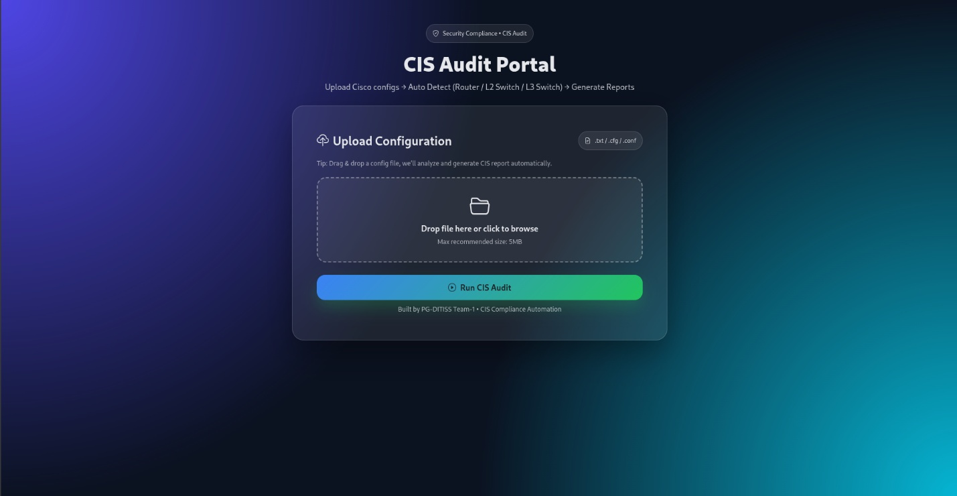
Fig. No 2
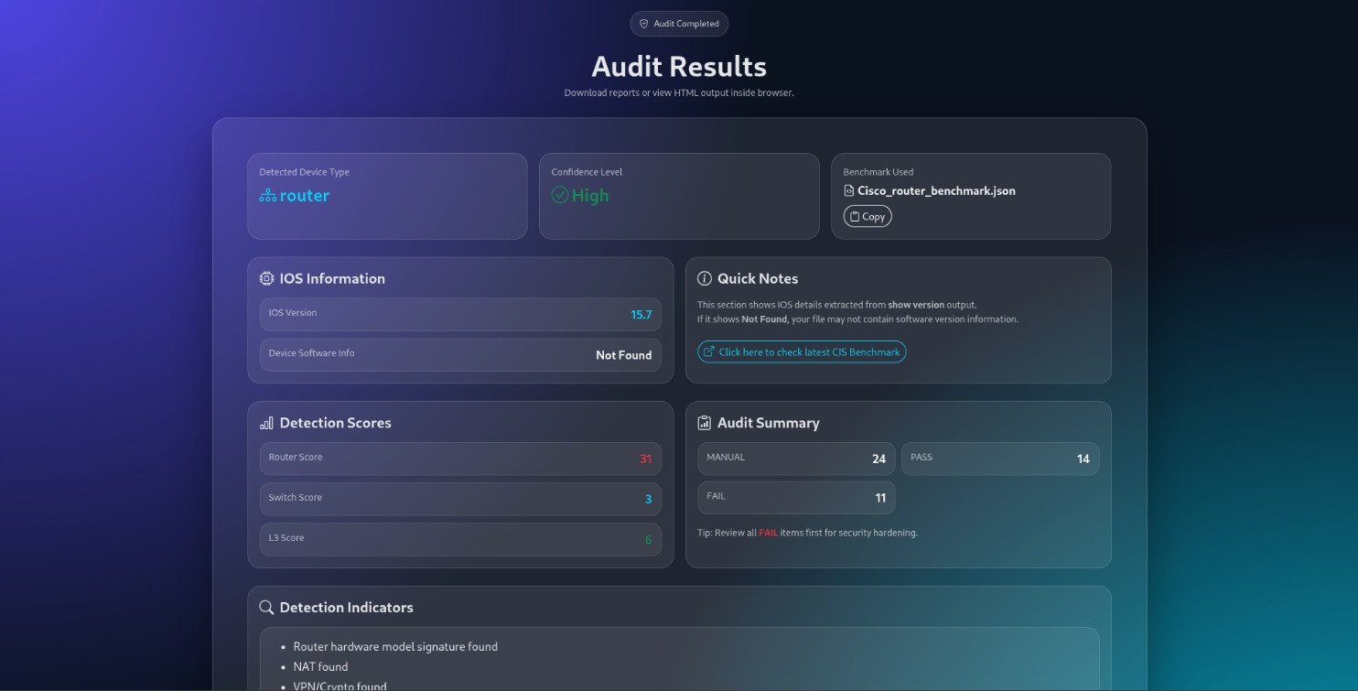Fig.No 3
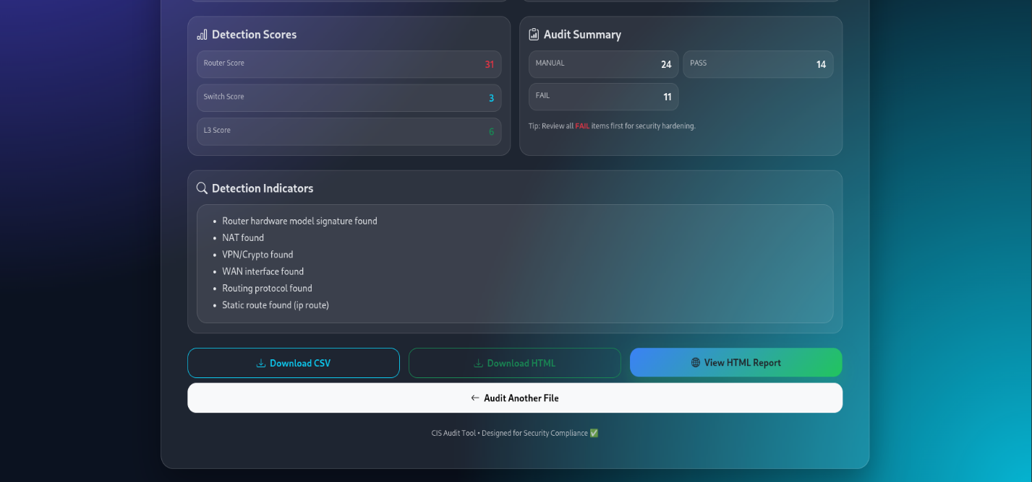
Fig.No 4
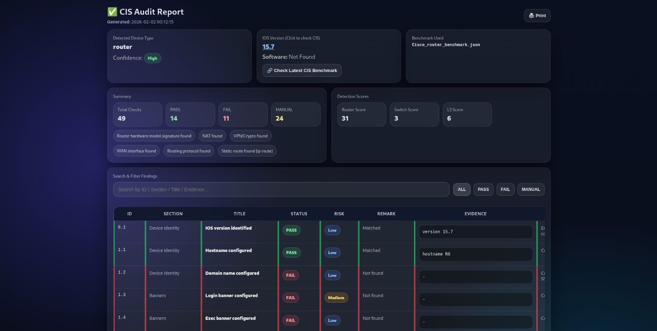
Fig.No 5

The application successfully audited router and switch configuration files
CIS benchmark rules were applied to evaluate security settings
Each control was categorized as PASS, FAIL, or MANUAL
Multiple misconfigurations were identified in default device settings
Compliance scores were calculated based on audit results
Risk levels were analyzed using CIS risk severity
CSV and HTML audit reports were generated successfully

LIMITATIONS:
Despite achieving its objectives, the Audit Based Application has certain limitations. The system currently supports only Cisco network devices, which restricts its applicability to other vendors. The audit process is limited to offline configuration file analysis, and real-time monitoring of network traffic is not supported.

Additionally, some security checks are categorized as MANUAL, requiring human verification. The rule coverage is limited to the academic scope of the project and does not include all possible CIS controls. The accuracy of audit results also depends on the correctness and completeness of the CIS benchmark rules used.

FUTURE ENHANCEMENTS:
The project can be further enhanced by introducing SSH-based live device access to enable real-time audits. A web-based dashboard can be developed to improve visualization and user interaction. Support for additional network vendors and device types can be added to increase scalability.

Future improvements may also include real-time configuration monitoring, automatic PDF compliance report generation, and automated remediation suggestions for failed controls. Integration with SIEM and logging tools can enhance security visibility, and scheduling periodic audits with alert mechanisms can improve continuous compliance monitoring.

CHAPTER 8

8. CONCLUSION

The Audit Based Application successfully demonstrates a standardized and structured approach to evaluating the security configurations of network infrastructure devices. By using CIS Benchmarks as the reference standard, the project ensures that Cisco routers and switches are audited against industry-recognized security best practices.

The application identifies configuration gaps, evaluates compliance levels, and provides meaningful security recommendations, thereby reducing risks caused by misconfigurations. The use of Python enables efficient checklist-based auditing and simplifies the analysis process. This project highlights the importance of security audits in maintaining a strong cybersecurity posture and shows how standardized frameworks can improve audit accuracy and consistency.

Overall, the Audit Based Application provides a structured approach to conducting security audits by standardizing the evaluation process. The project enhances understanding of cybersecurity audits, compliance checking, and risk identification, making it suitable for academic and practical use.

Source Code:

The following code snippets represent core modules of the application.

Fig.No 4
import os import re import json import uuid
import pandas as pd
from datetime import datetime
from flask import Flask, render_template, request, redirect, url_for, send_file, flash

# ============================== # ✅ CONFIG
# ==============================
UPLOAD_FOLDER = "uploads" OUTPUT_FOLDER = "output"
ROUTER_JSON = "Cisco_router_benchmark.json" SWITCH_L2_JSON = "switch_benchmark.json" SWITCH_L3_JSON = "l3_switch.json" ALLOWED_EXTENSIONS = {"txt", "cfg", "conf"}
app = Flask( name )
app.secret_key = "supersecretkey" # ✅ change later app.config["UPLOAD_FOLDER"] = UPLOAD_FOLDER app.config["OUTPUT_FOLDER"] = OUTPUT_FOLDER
os.makedirs(app.config["UPLOAD_FOLDER"], exist_ok=True) os.makedirs(app.config["OUTPUT_FOLDER"], exist_ok=True) # ==============================
# ✅ HELPERS
# ==============================
def allowed_file(filename):
return "." in filename and filename.rsplit(".", 1)[1].lower() in ALLOWED_EXTENSIONS def read_config(filepath):
with open(filepath, "r", encoding="utf-8", errors="ignore") as f: return f.read()
def normalize_cfg(cfg: str) -> str:
return cfg.replace("\r\n", "\n").replace("\r", "\n") def extract_ios_version(cfg: str):
m = re.search(r"(?im)^\s*version\s+([0-9A-Za-z().]+)\s*$", cfg) if m:
return m.group(1).strip()
m = re.search(r"(?i)\bversion\s+([0-9A-Za-z().]+)", cfg) if m:
return m.group(1).strip() return "Not Found"
def extract_device_software_line(cfg: str):
m = re.search(r"(?im)^\s*(Cisco IOS Software.*)$", cfg) if m:
return m.group(1).strip() return "Not Found"
# ============================== # ✅ CIS URL AUTO BASED ON DEVICE # ==============================
def get_cis_benchmark_url(device_type: str, device_software_info: str): dt = (device_type or "").lower().strip()
info = (device_software_info or "").lower()
fallback = "https://www.cisecurity.org/cis-benchmarks" if dt == "router":
return "https://www.cisecurity.org/benchmark/cisco_ios"

if dt in ["switch_l2", "switch_l3"]:
if "ios-xe" in info or "ios xe" in info:

return "https://www.cisecurity.org/benchmark/cisco"

return "https://www.cisecurity.org/benchmark/cisco" return fallback
# ==============================
# ✅ DEVICE TYPE DETECTION
# ==============================
def detect_device_type(cfg: str): cfg_lower = cfg.lower() indicators = []
router_score = 0
switch_score = 0
l3_score = 0 router_models = [
r"\bisr\b", r"\basr\b", r"\bcisco\s*29\d{2}\b", r"\bcisco\s*19\d{2}\b", r"\bcisco\s*39\d{2}\b",
]
switch_models = [ r"\bws-c\d{4}\b", r"\bcatalyst\b", r"\bc\d{4}\b", r"\bnexus\b",
]
for pat in router_models:
if re.search(pat, cfg_lower): router_score += 8
indicators.append("Router hardware model signature found") break
for pat in switch_models:
if re.search(pat, cfg_lower): switch_score += 8
indicators.append("Switch hardware model signature found") break
switch_patterns = [
(r"^\s*switchport\b", 6, "Switchport found"), (r"^\s*spanning-tree\b", 6, "Spanning-tree found"), (r"^\s*vlan\s+\d+\b", 4, "VLAN config found"), (r"^\s*channel-group\b", 3, "Port-channel config found"), (r"^\s*ip dhcp snooping\b", 5, "DHCP snooping found"),
]
for pat, score, reason in switch_patterns: if re.search(pat, cfg, re.M | re.I):
switch_score += score indicators.append(reason)
router_patterns = [
(r"^\s*ip nat\b", 6, "NAT found"),
(r"^\s*crypto (isakmp|ikev2|ipsec)\b", 6, "VPN/Crypto found"), (r"^\s*interface\s+(Serial|Tunnel|Dialer|Cellular)\d+", 6, "WAN interface found"), (r"^\s*router\s+(bgp|eigrp|rip|isis)\b", 5, "Routing protocol found"),
]
for pat, score, reason in router_patterns: if re.search(pat, cfg, re.M | re.I):
router_score += score indicators.append(reason)
if re.search(r"^\s*interface\s+Vlan\d+\b", cfg, re.M | re.I): switch_score += 5
l3_score += 8
indicators.append("SVI found (interface VlanX)") if re.search(r"^\s*ip routing\b", cfg, re.M | re.I):
switch_score += 4

Fig.No 5
indicators.append("ip routing enabled")
if re.search(r"^\s*ip route\b", cfg, re.M | re.I): switch_score += 3
l3_score += 6
indicators.append("Static route found (ip route)") if re.search(r"^\s*no switchport\b", cfg, re.M | re.I):
switch_score += 3
l3_score += 6
indicators.append("Routed port found (no switchport)") if l3_score >= 12 and switch_score >= 10:
device_type = "switch_l3"
elif router_score >= switch_score + 4 and router_score >= 10: device_type = "router"
elif switch_score >= router_score + 4 and switch_score >= 10: device_type = "switch_l2"
else:
device_type = "unknown" if device_type == "unknown":
confidence = "Low" else:
top = max(router_score, switch_score, l3_score)
confidence = "High" if top >= 22 else "Medium" if top >= 14 else "Low" scores = {
"router_score": router_score, "switch_score": switch_score, "l3_score": l3_score,
}
return device_type, confidence, indicators[:15], scores
Fig.No 6
# ============================== # ✅ RULE HELPERS
# ==============================
def extract_blocks(cfg: str, header_regex: str): lines = cfg.splitlines()
blocks = [] i = 0
while i < len(lines):
if re.search(header_regex, lines[i], re.I): block = [lines[i]]
i += 1
while i < len(lines): line = lines[i]
if line.strip() == "!": break
if re.match(r"^[A-Za-z]", line): break
block.append(line) i += 1
blocks.append("\n".join(block)) i += 1
return blocks
def evidence_regex(text, pattern, max_lines=8): ev = []
for line in text.splitlines():
if re.search(pattern, line, re.I): ev.append(line.rstrip())
if len(ev) >= max_lines: break
return "\n".join(ev) if ev else "-"

Fig.No 7

def evidence_all_lines(text, pattern, max_lines=200): ev = []
for line in text.splitlines():
if re.search(pattern, line, re.I): ev.append(line.rstrip())
if not ev:
return "-"
return "\n".join(ev[:max_lines])
def extract_banner(cfg_text: str, banner_type: str = "login"):
start = re.search(rf"(?im)^\s*banner\s+{banner_type}\s+(\S+)\s*$", cfg_text) if not start:
return None
start_delim = start.group(1).strip() after = cfg_text[start.end():] possible_end_delims = [start_delim]
if start_delim.startswith("^") and len(start_delim) > 2: possible_end_delims.append("^C")
possible_end_delims.append("^C") seen = set()
possible_end_delims = [d for d in possible_end_delims if not (d in seen or seen.add(d))] for d in possible_end_delims:
m_end = re.search(rf"(?im)^\s*{re.escape(d)}\s*$", after) if m_end:
content = after[:m_end.start()].strip("\n")
return f"banner {banner_type} {start_delim}\n{content}\n{d}" return None
elif risk == "medium":
risk_badge = '<span class="pill pill-yellow">Medium</span>' else:
risk_badge = '<span class="pill pill-blue">Low</span>' evidence = str(r.get("Evidence", "")).strip()
if evidence == "" or evidence.lower() in ["nan", "none"]: evidence = "—"
remark = str(r.get("Remark", "")).strip()
if remark == "" or remark.lower() in ["nan", "none"]: remark = "—"
recommendation = str(r.get("Recommendation", "")).strip()
if recommendation == "" or recommendation.lower() in ["nan", "none"]: recommendation = "—"
rows += f"""
<tr data-status="{status}">
<td class="mono">{r['ID']}</td>
<td class="muted">{r['Section']}</td>
<td class="title">{r['Title']}</td>
<td>{status_badge}</td>
<td>{risk_badge}</td>
<td class="muted">{remark}</td>
<td class="evidence"><pre>{evidence}</pre></td>
<td class="muted">{recommendation}</td>
</tr> """

Fig.No 8
Out Put:

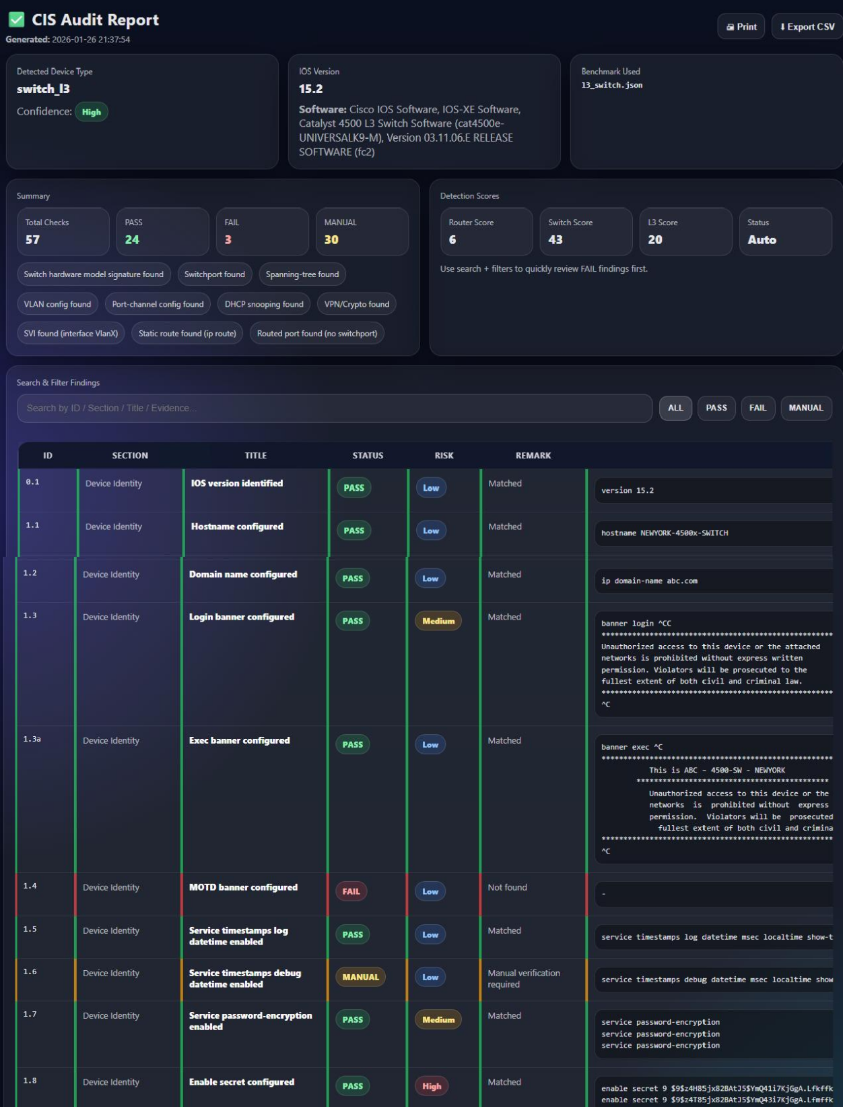
Fig.No 9

REFERENCES

Center for Internet Security (CIS)

CIS Benchmarks – Security configuration guidelines for network devices.

- Cisco Systems
Cisco IOS Security Configuration Guides.
Referenced for understanding router and switch security configurations.

Cisco Systems Documentation

Cisco IOS Security Configuration and Hardening Guides.

9tut.com

CCNA lab typologies and networking reference materials.

Python Official Documentation

Python programming language reference for automation and scripting.

